## Design

### Website Design

#### Media Query Design

|  |  |
| --- | --- |
| For minimum screen width of 768px  (For desktop only) | h1 {font-size:30px;}  * {font-size:20px;}  footer,a,#formbutton{font-size:18px}  html{background-color:teal;}  body{border-radius:15px;width:95%;padding:25px;background-color:slategray;}  div{border-radius:50px;width:95%;}  main{margin:70px;}  nav li{margin-left:50px;margin-right:42px;}  #questionbutton{display:inline;color:lightgrey;text-decoration:none;border-radius:10px;background-color:darkslategray;margin:auto;width:7%;padding: 10px;} |
| Full screen width  (For tablets, mobiles) | h1 {font-family: Book Antiqua;font-size:20px;}  * {font-family:Palatino Linotype;font-size:15px;}  footer,a,#formbutton{font-size:12px}  header,footer{background-color:darkslategray;color:lightgrey;text-align:center;}  body{padding:25px;background-color:slategray;}  div{border-radius:40px;padding:10px;background-color:gainsboro;color:slategray;margin-top:5px;margin-bottom:5px;display:block;text-align:center;}  div a{text-decoration:none;color:darkslategray;}  div a:hover{color:teal;}  main{margin:10px}  nav ul{list-style-type:none;overflow:hidden;}  nav li{float:left;display:inline;}  nav li a{font-size:14px;display:block;color:darkslategray;text-decoration:none;border-radius:10px;width:100px;padding:7.5px;margin:2.5px;background-color:lightgray;}  nav li a:hover{color:teal;}  #formbutton{display:block;color:lightgrey;text-decoration:none;border-radius:10px;background-color:darkslategray;margin:auto;width:25%;padding: 10px;}  form{font-weight:bold;}  div h1{color:darkslategray;text-decoration:underline;}  #questionbutton{display:inline;color:lightgrey;text-decoration:none;border-radius:10px;background-color:darkslategray;margin:auto;width:7%;padding: 10px;}  #questionbutton:focus{background-color:teal;}  .question{background-color:#F6F6F6;margin-left:15px;border-style:solid;border-color:slategray;color:darkslategray;}  table {border-collapse: collapse;}  table, th, td {border: 1px solid slategray;background-color:#F6F6F6;margin: auto;width: 50%;color:darkslategray;} |

#### Wireframes

For mobile/tablet devices…

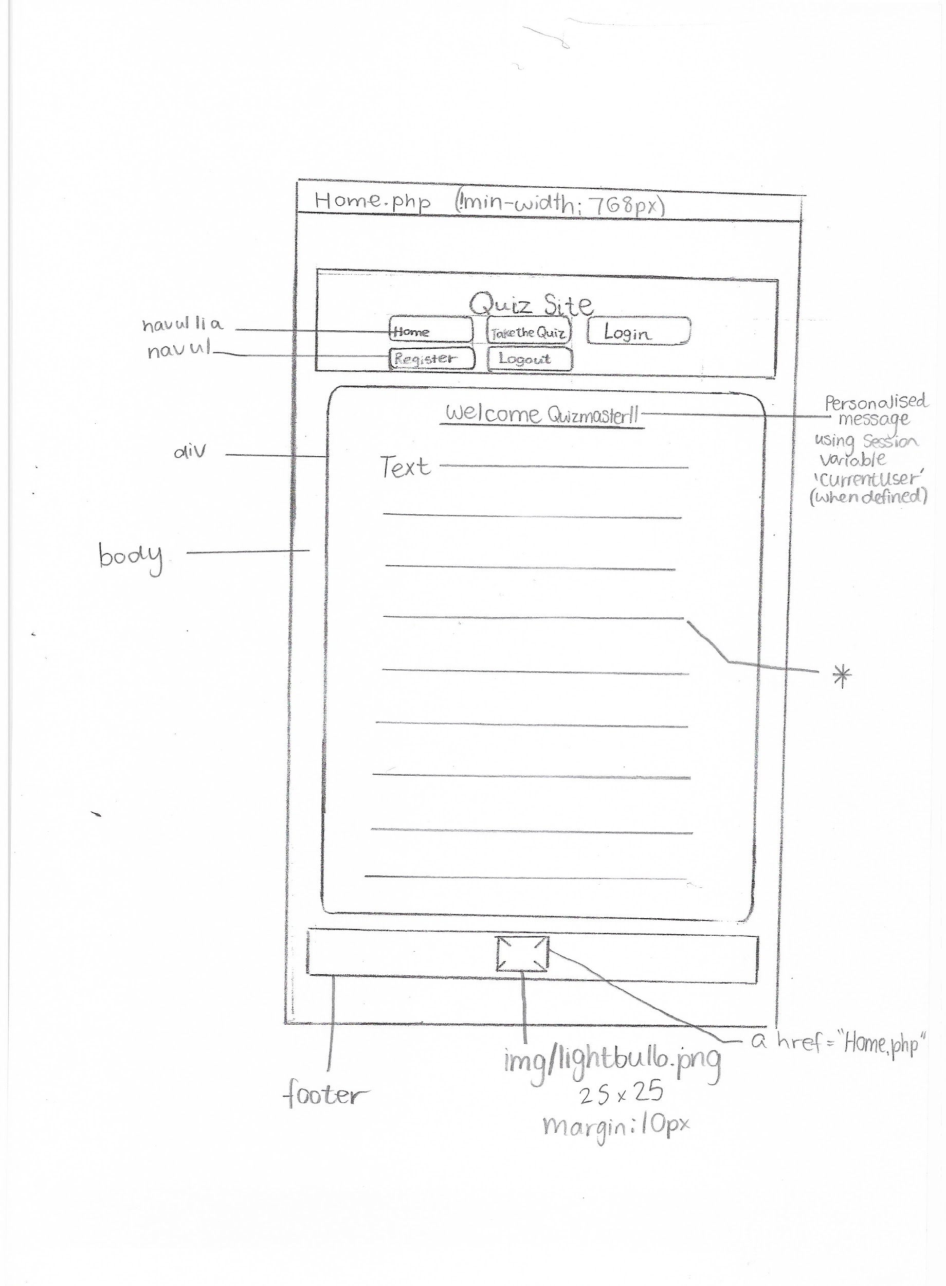

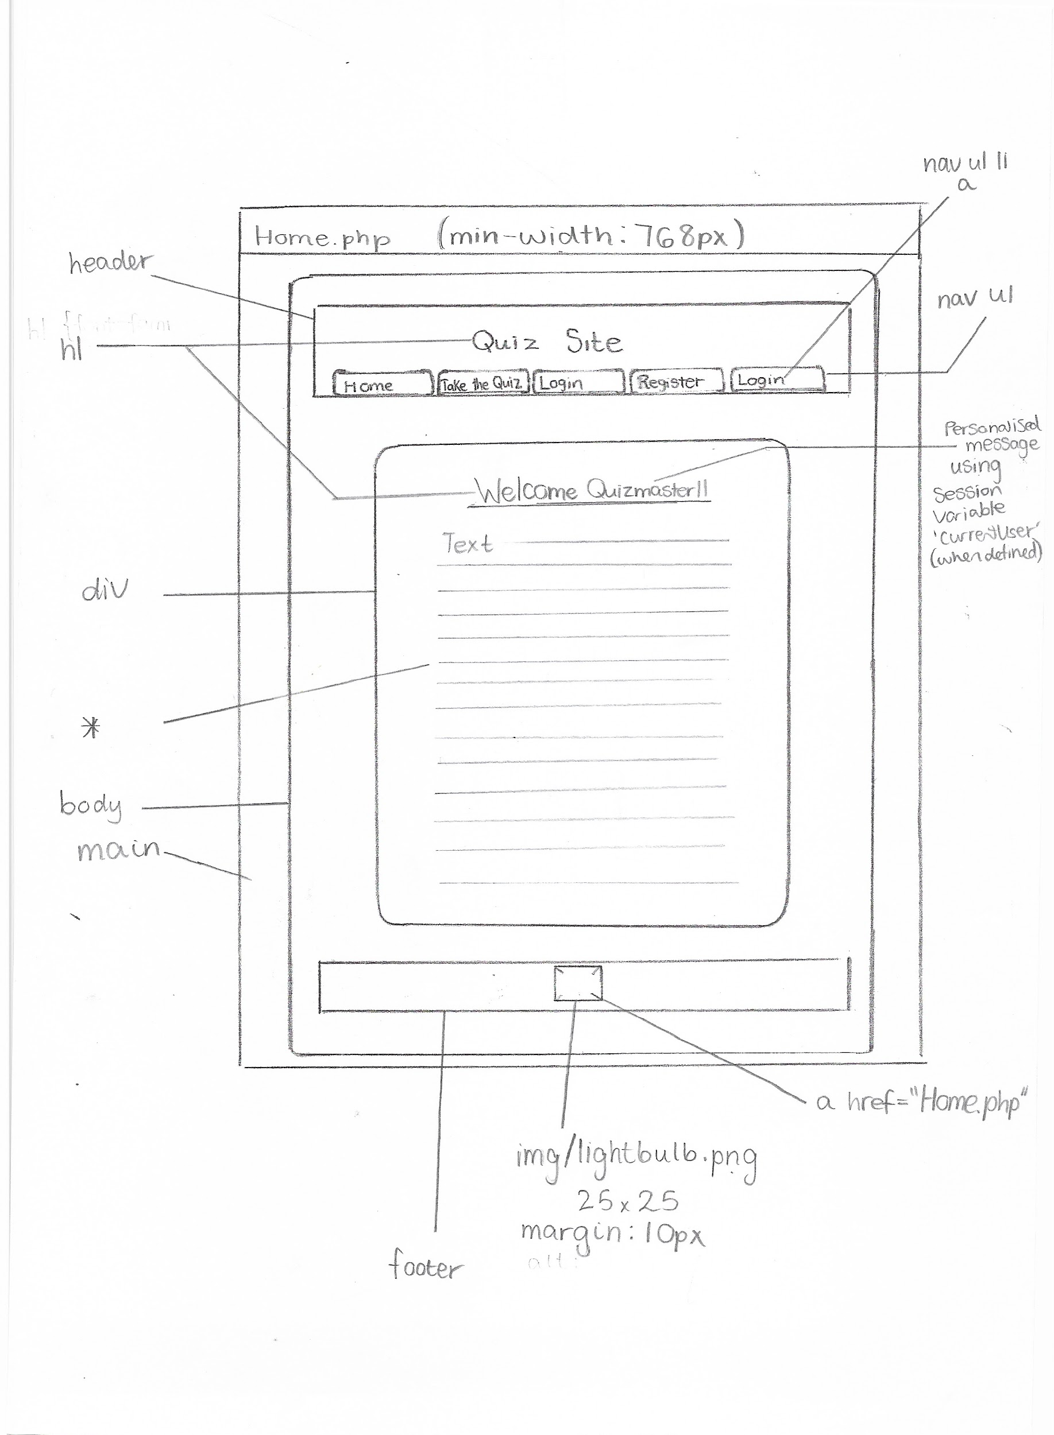

For desktops…

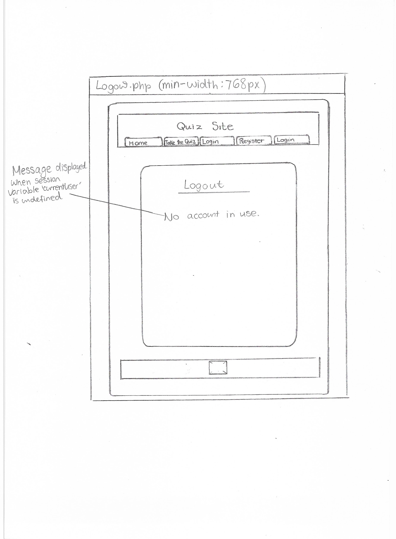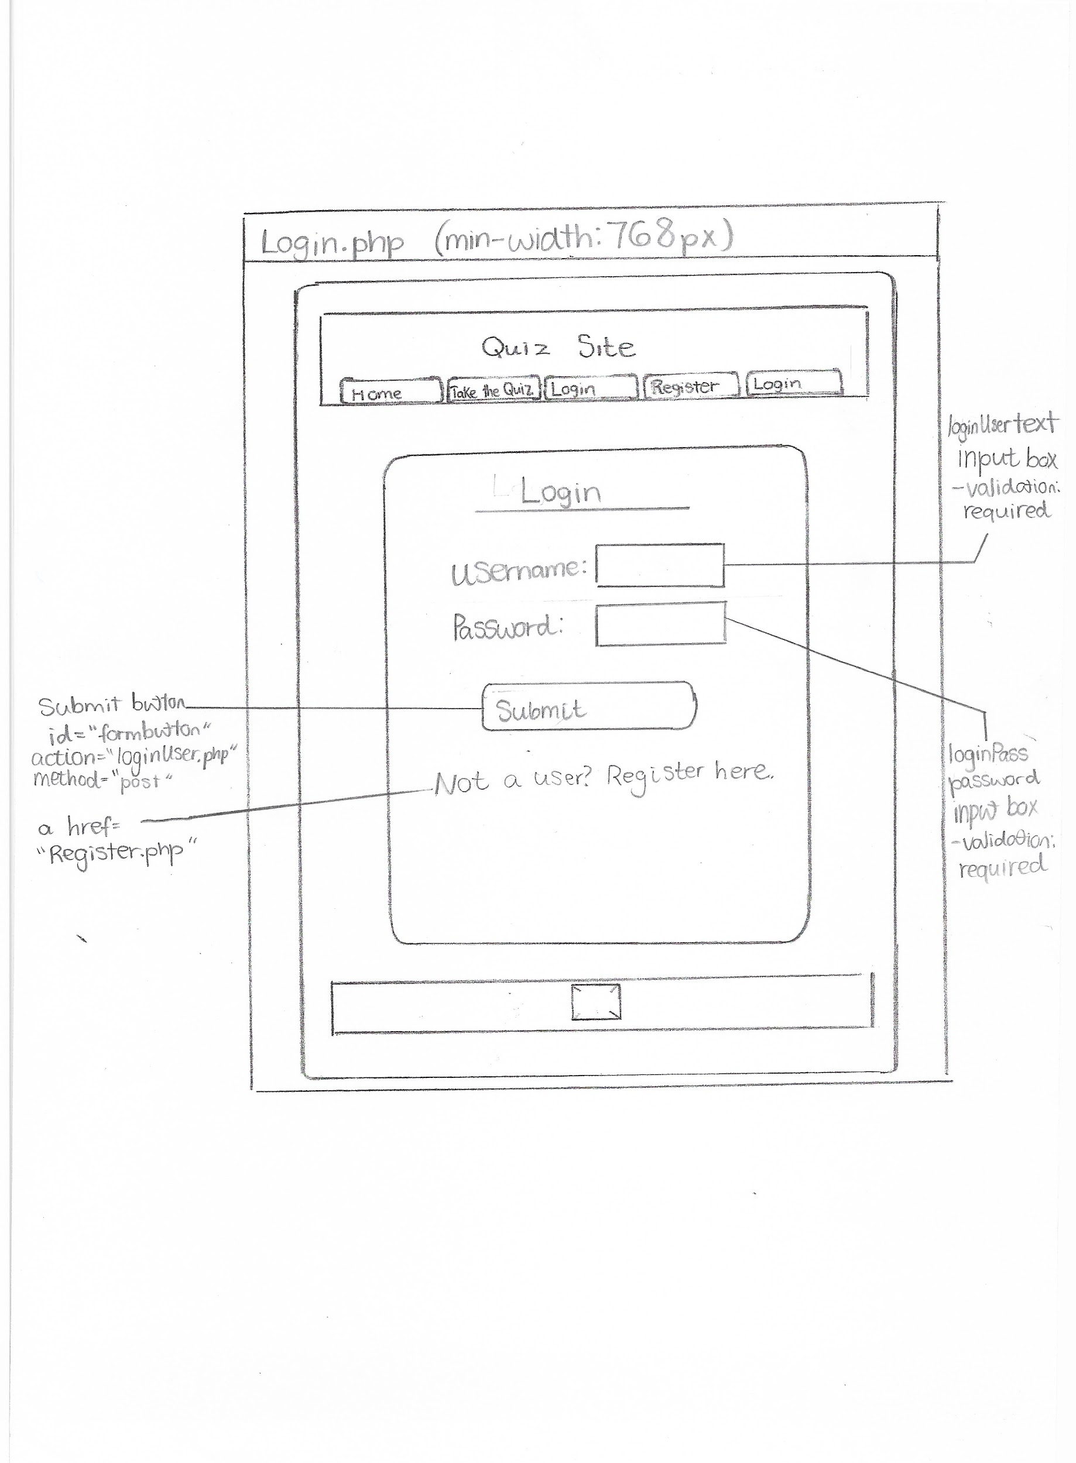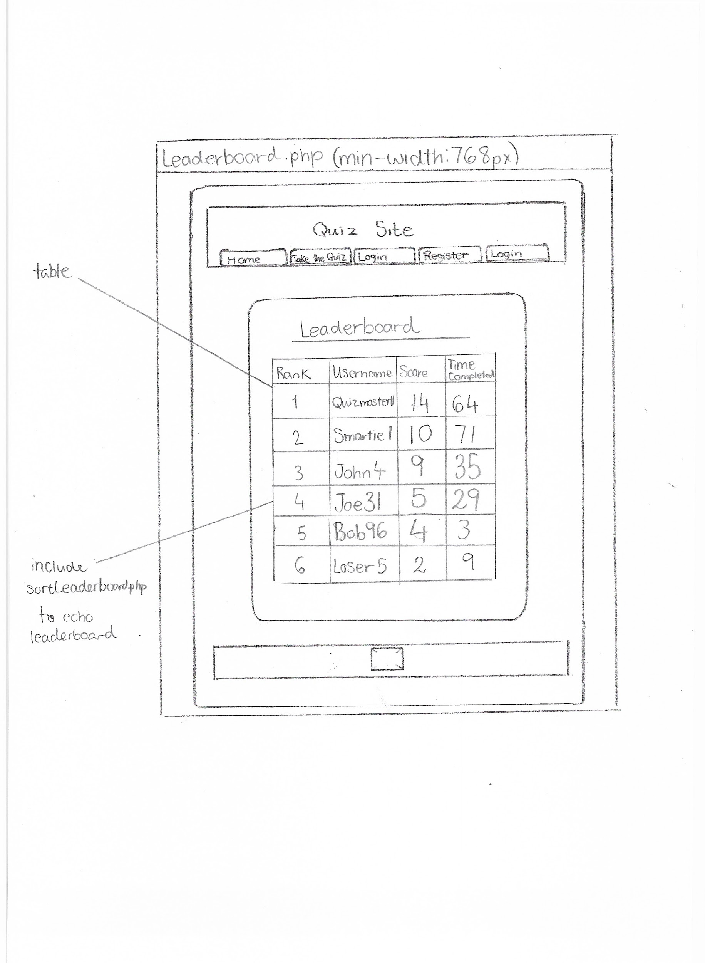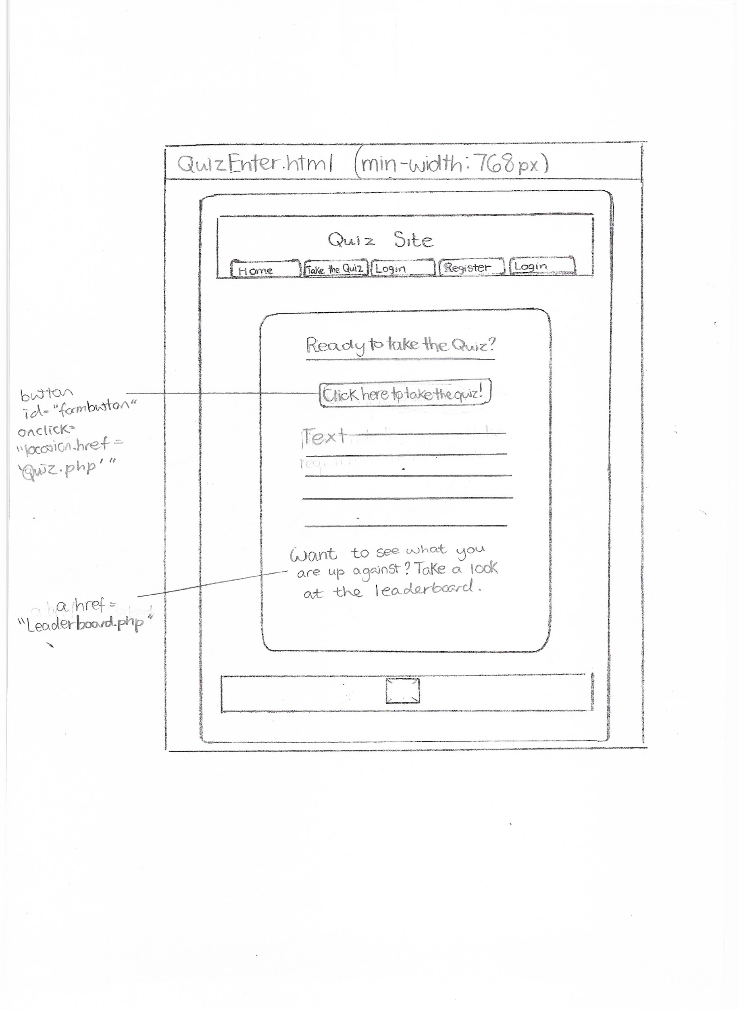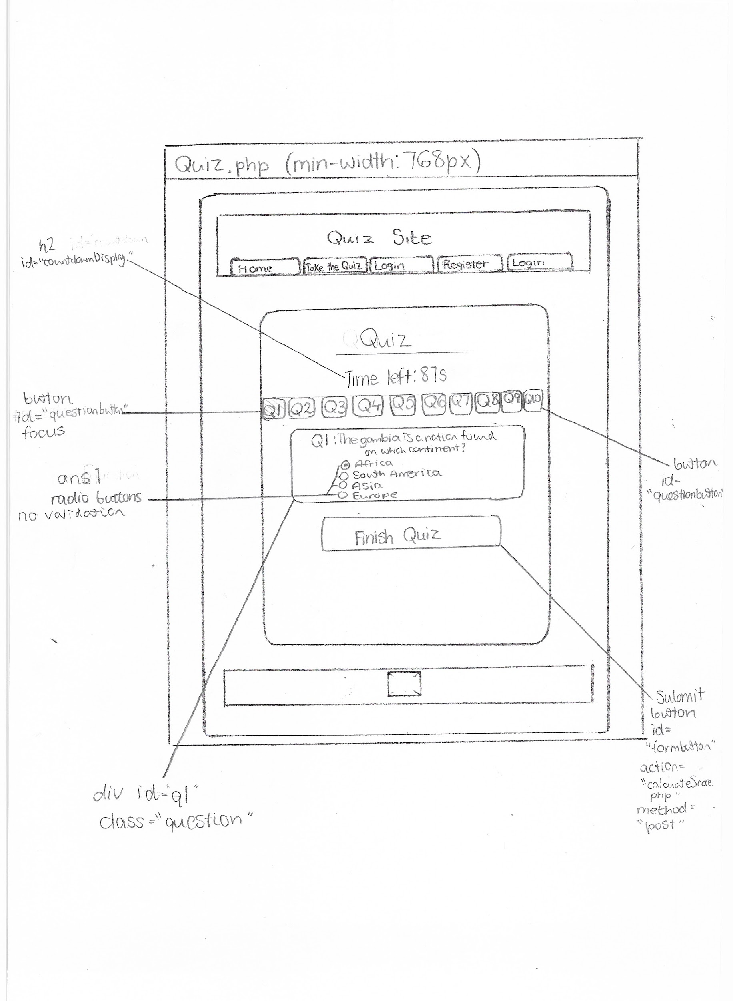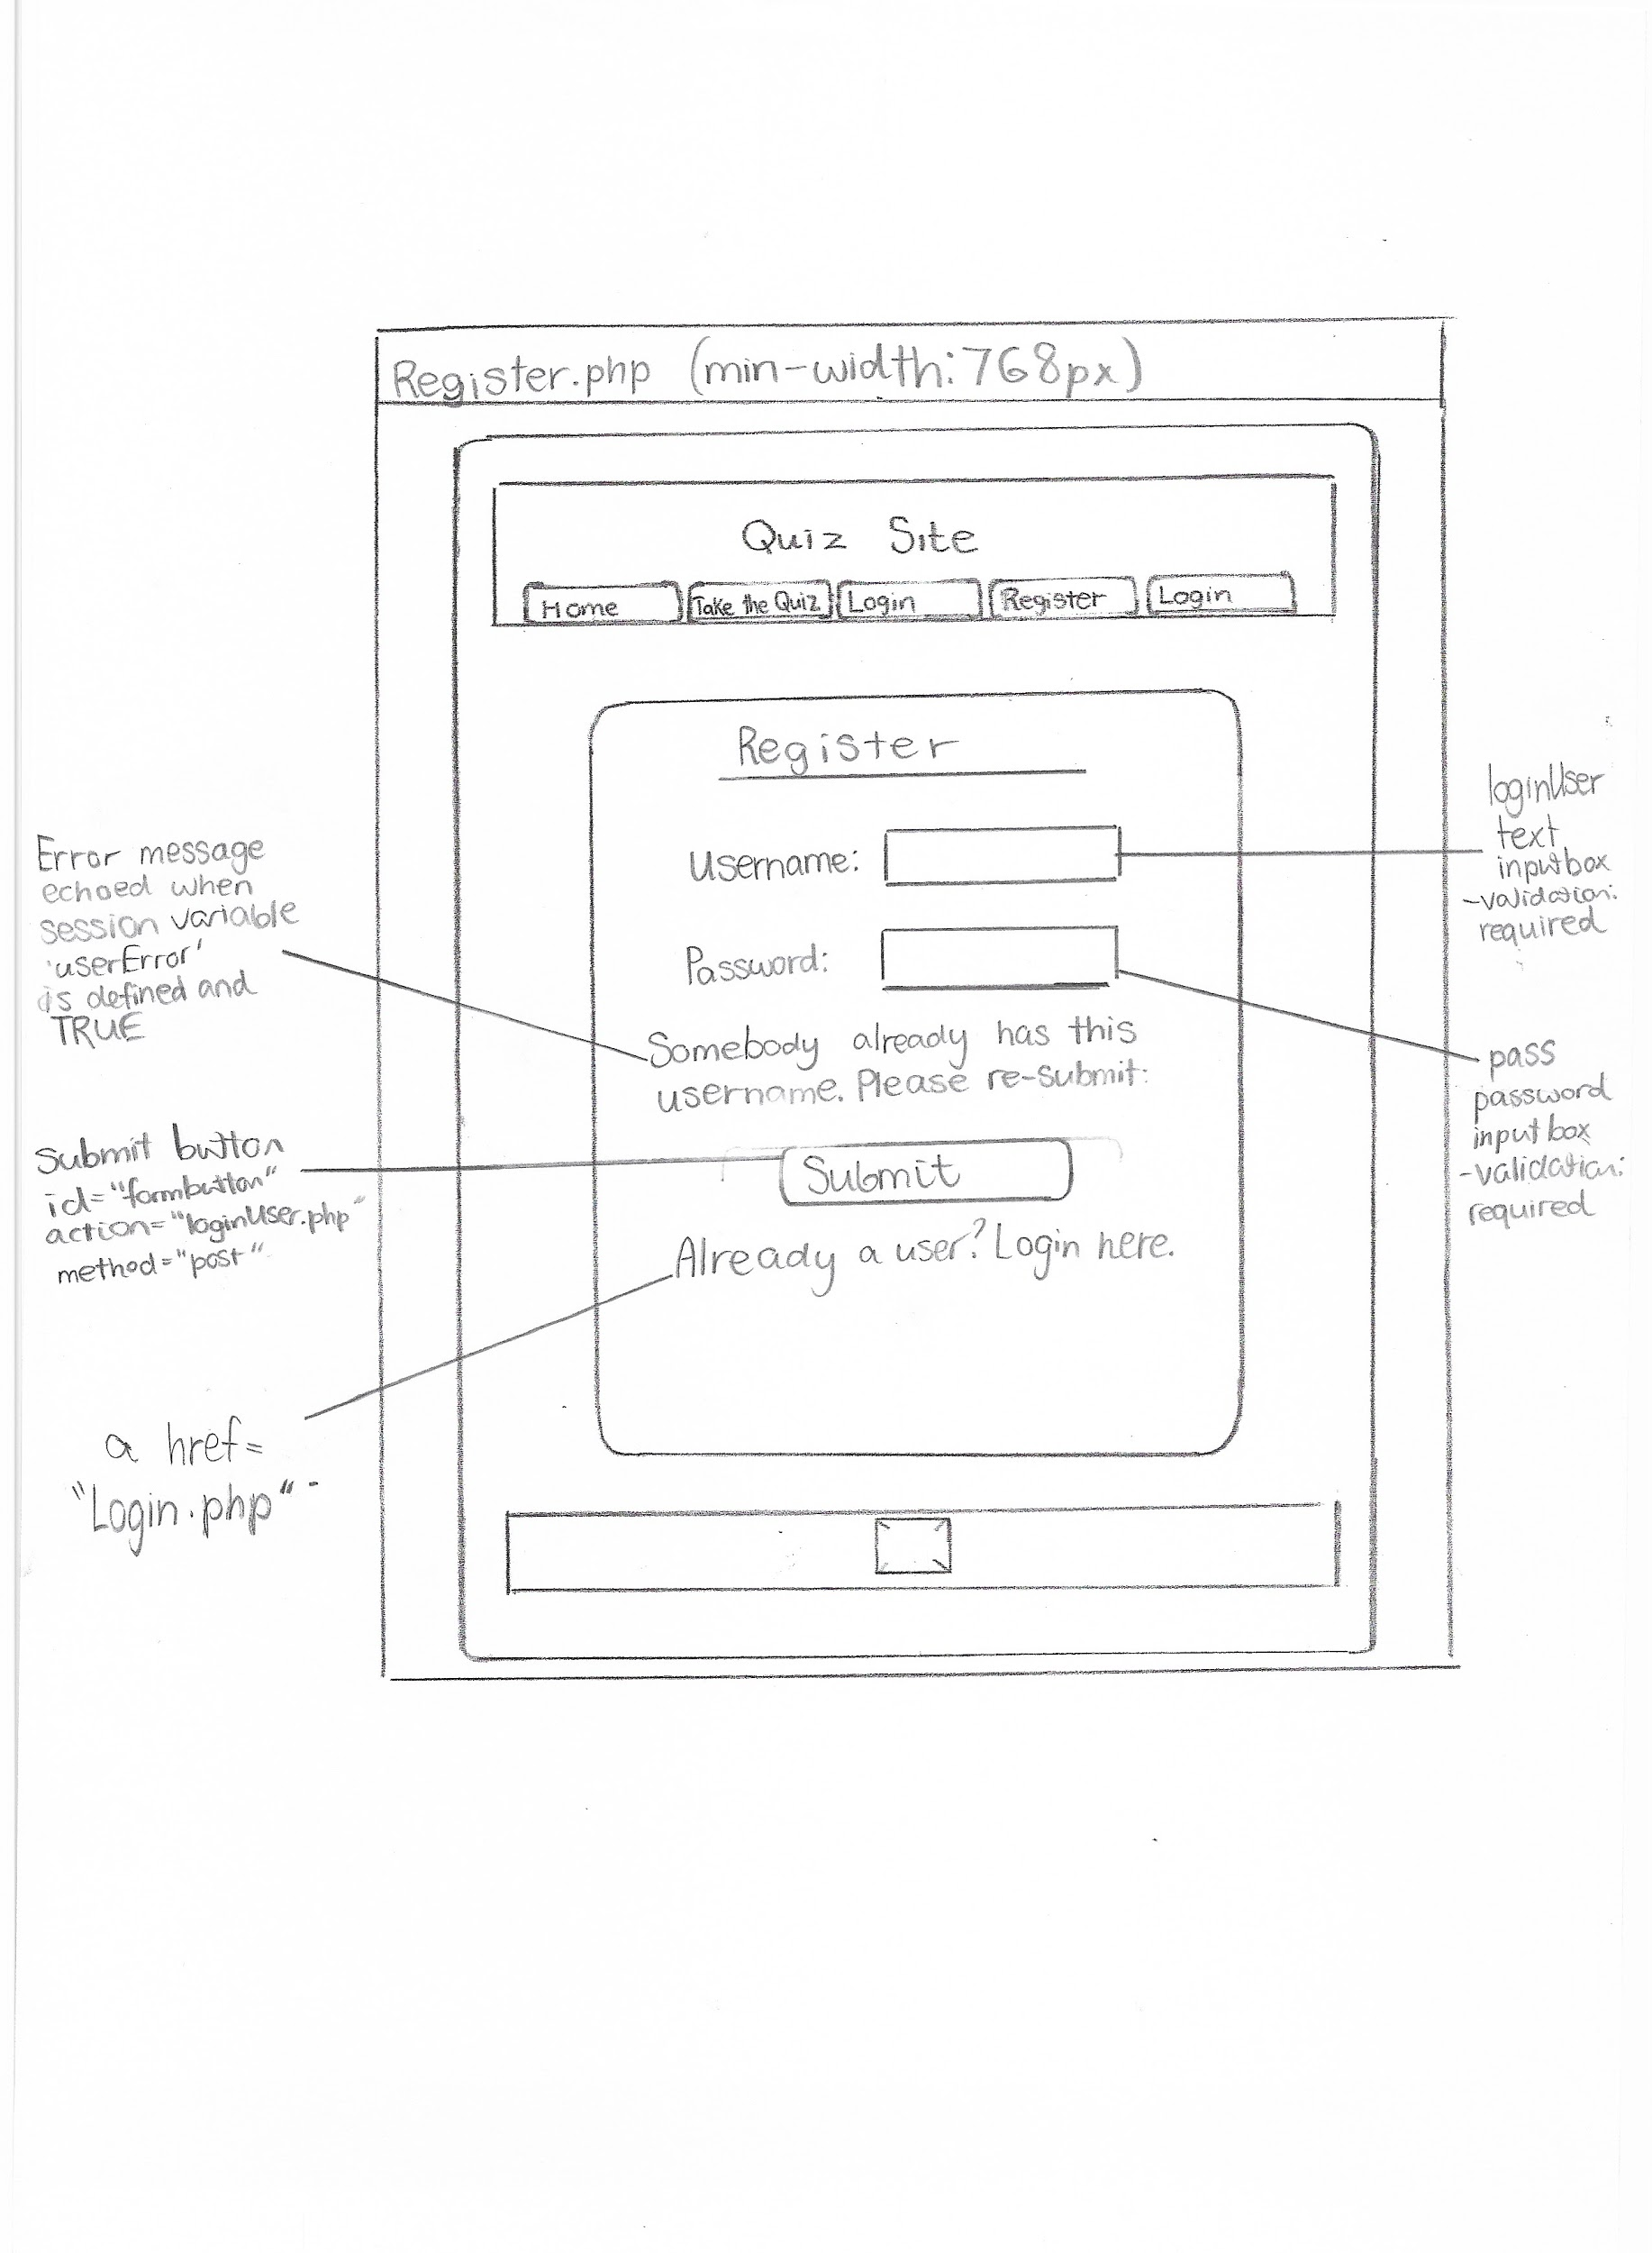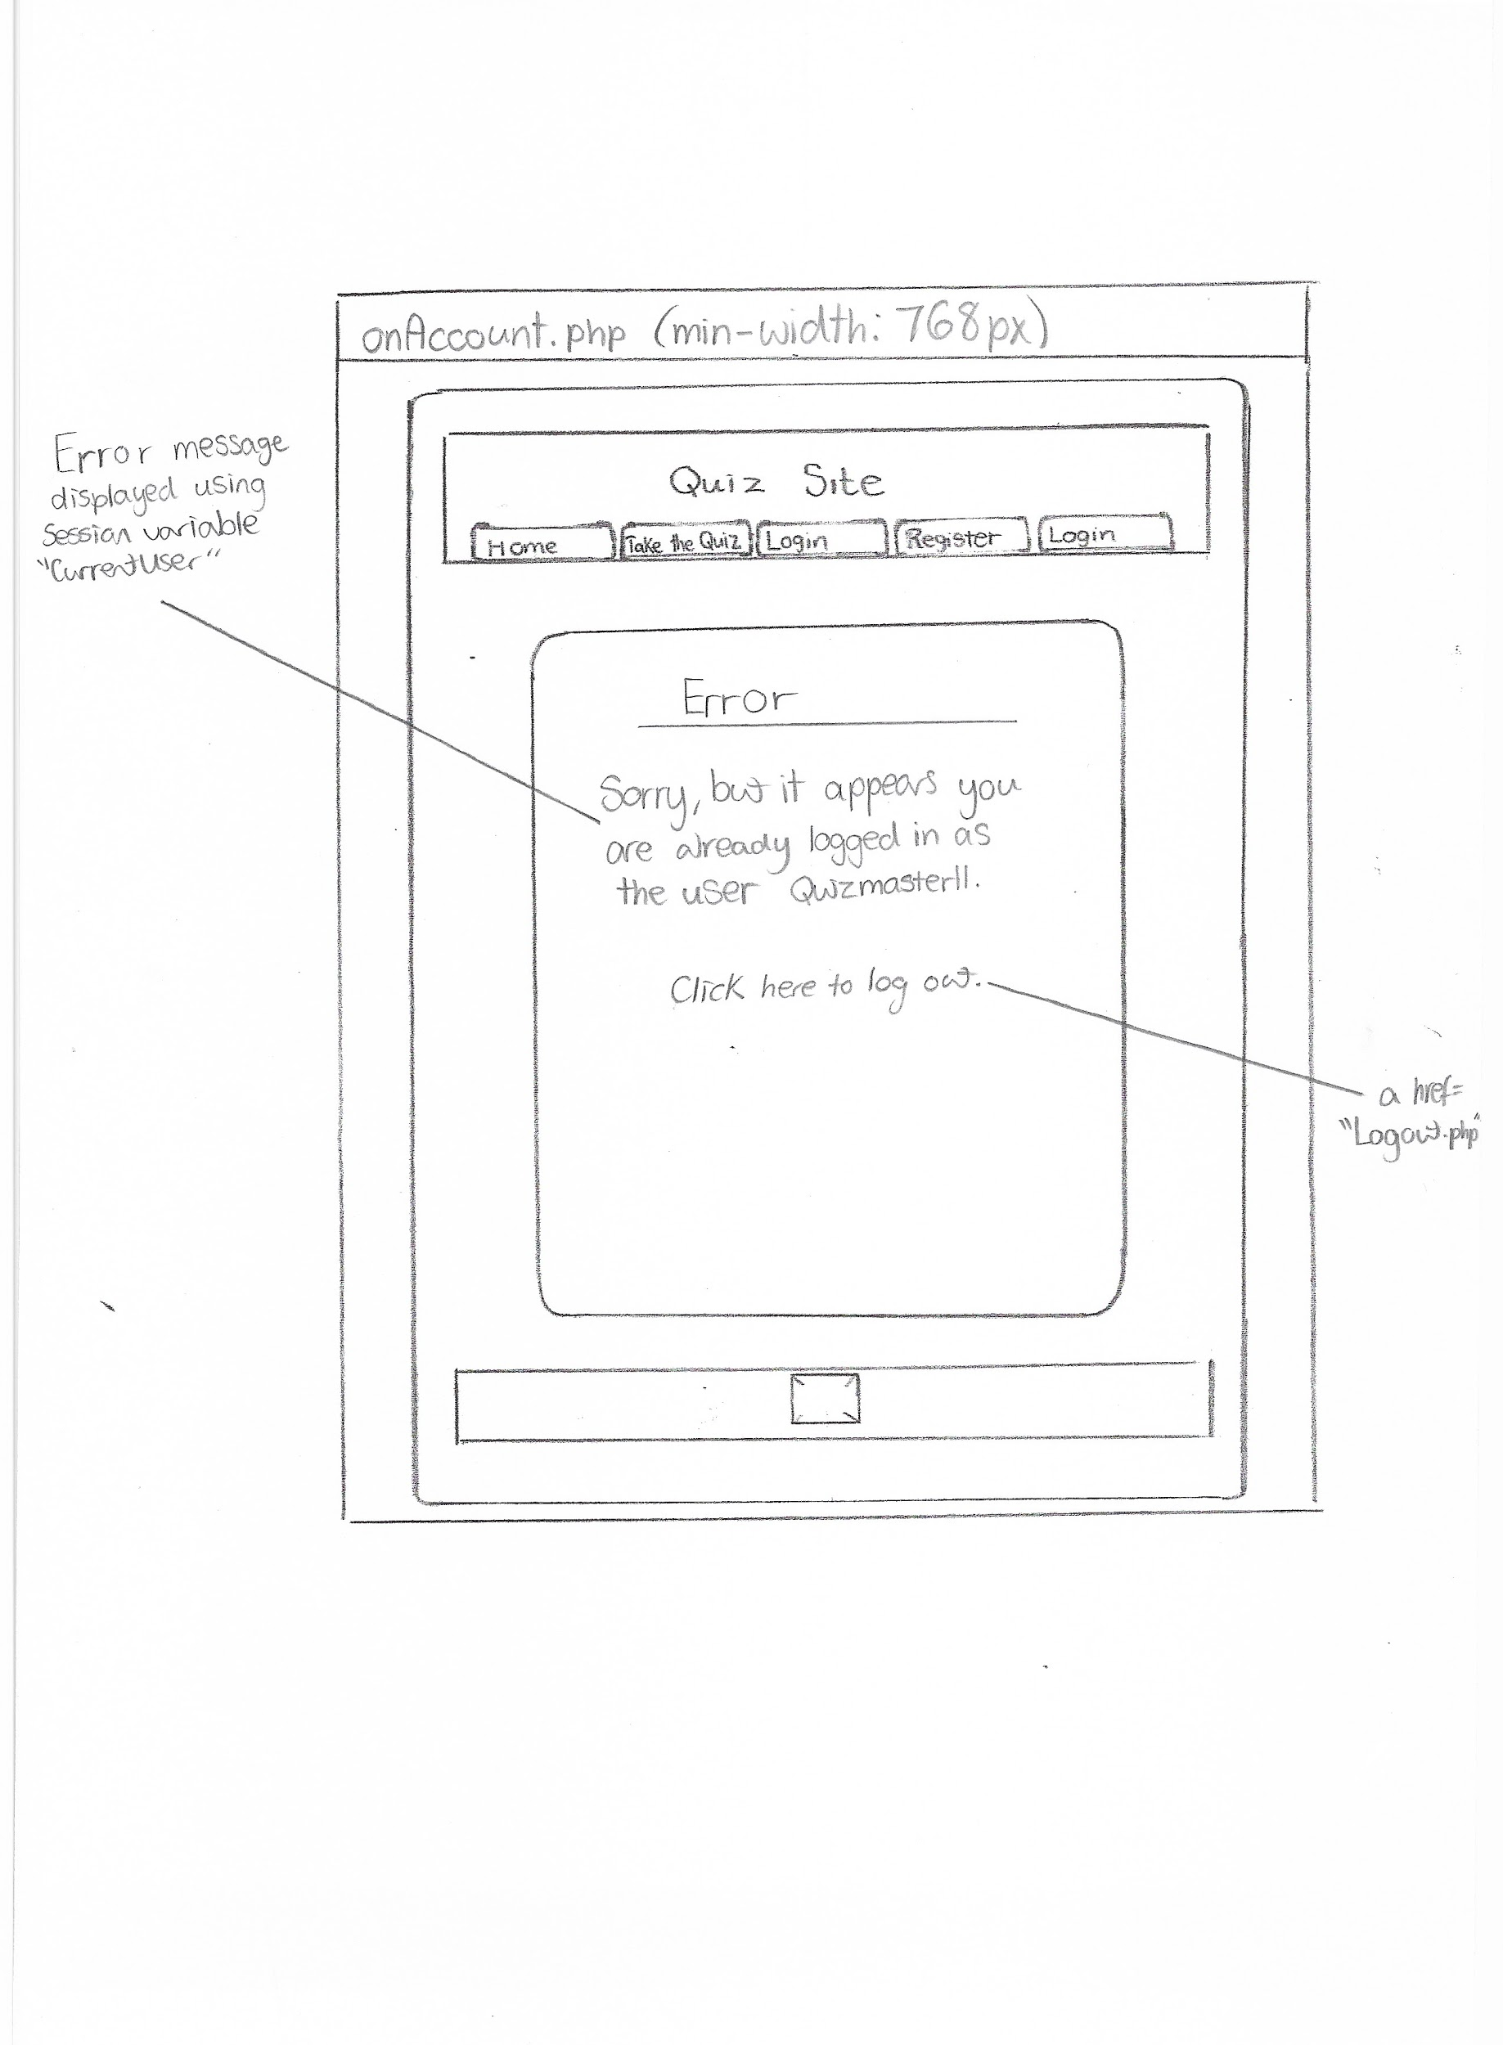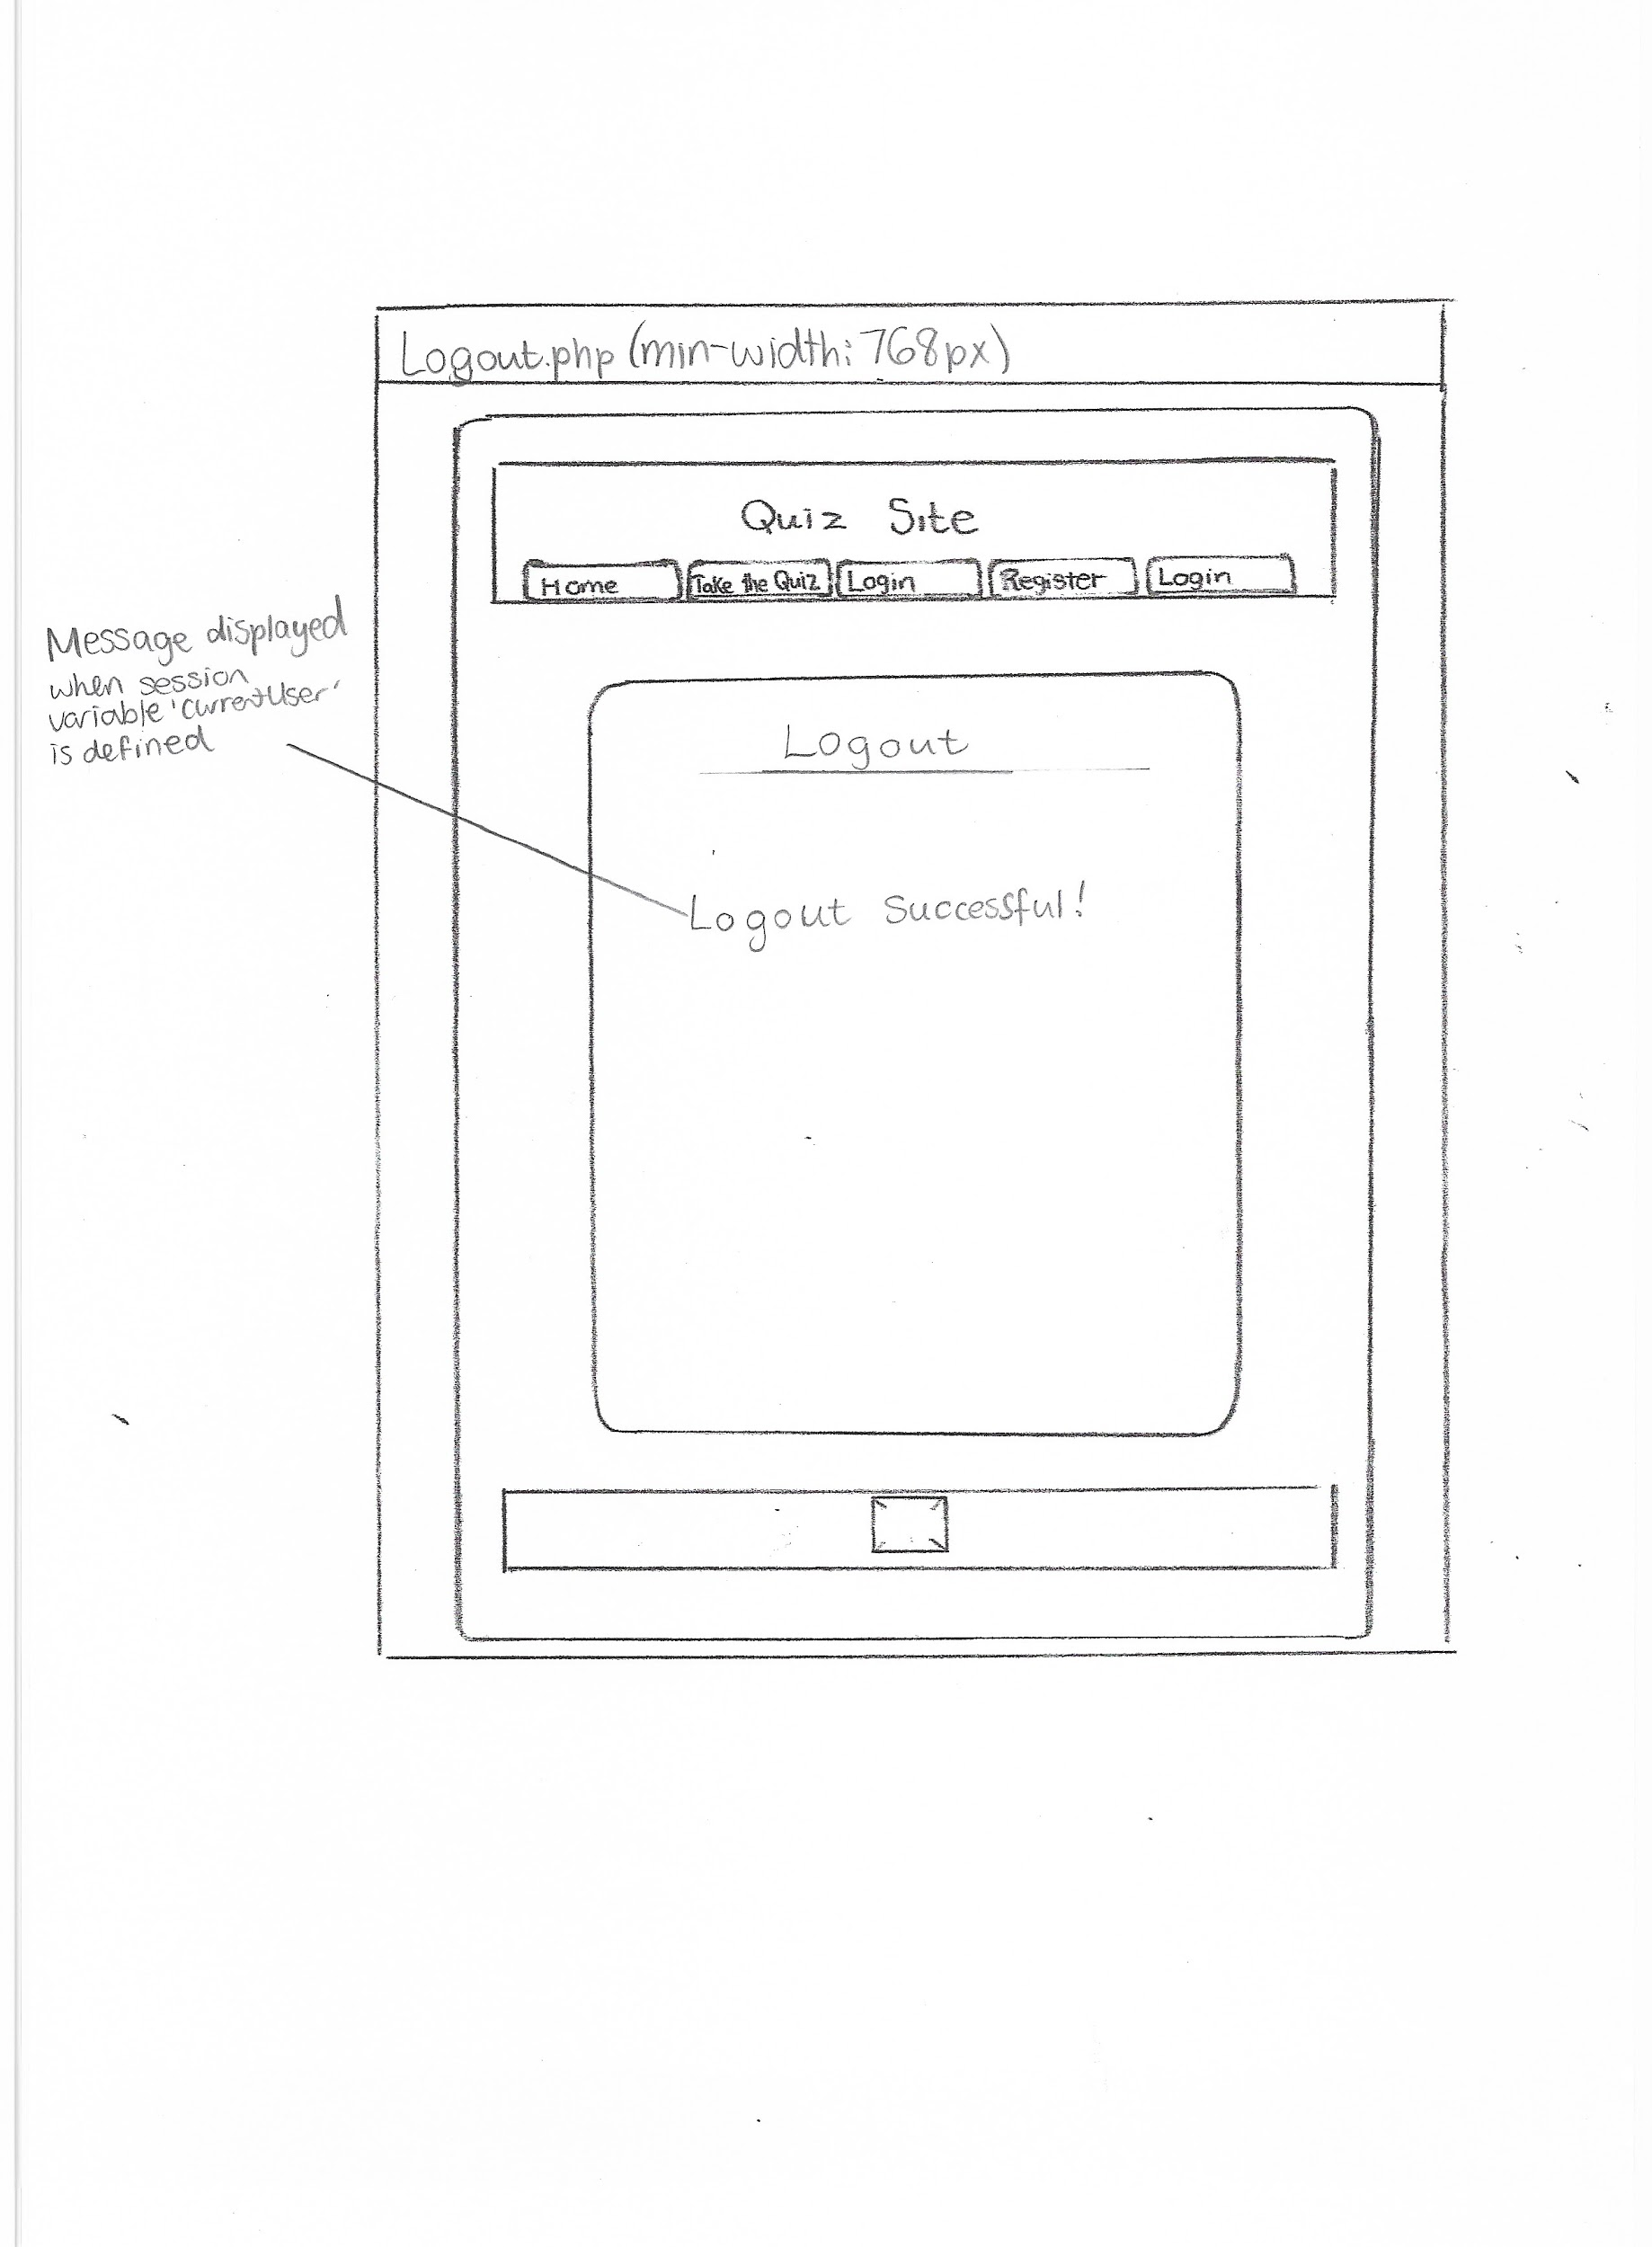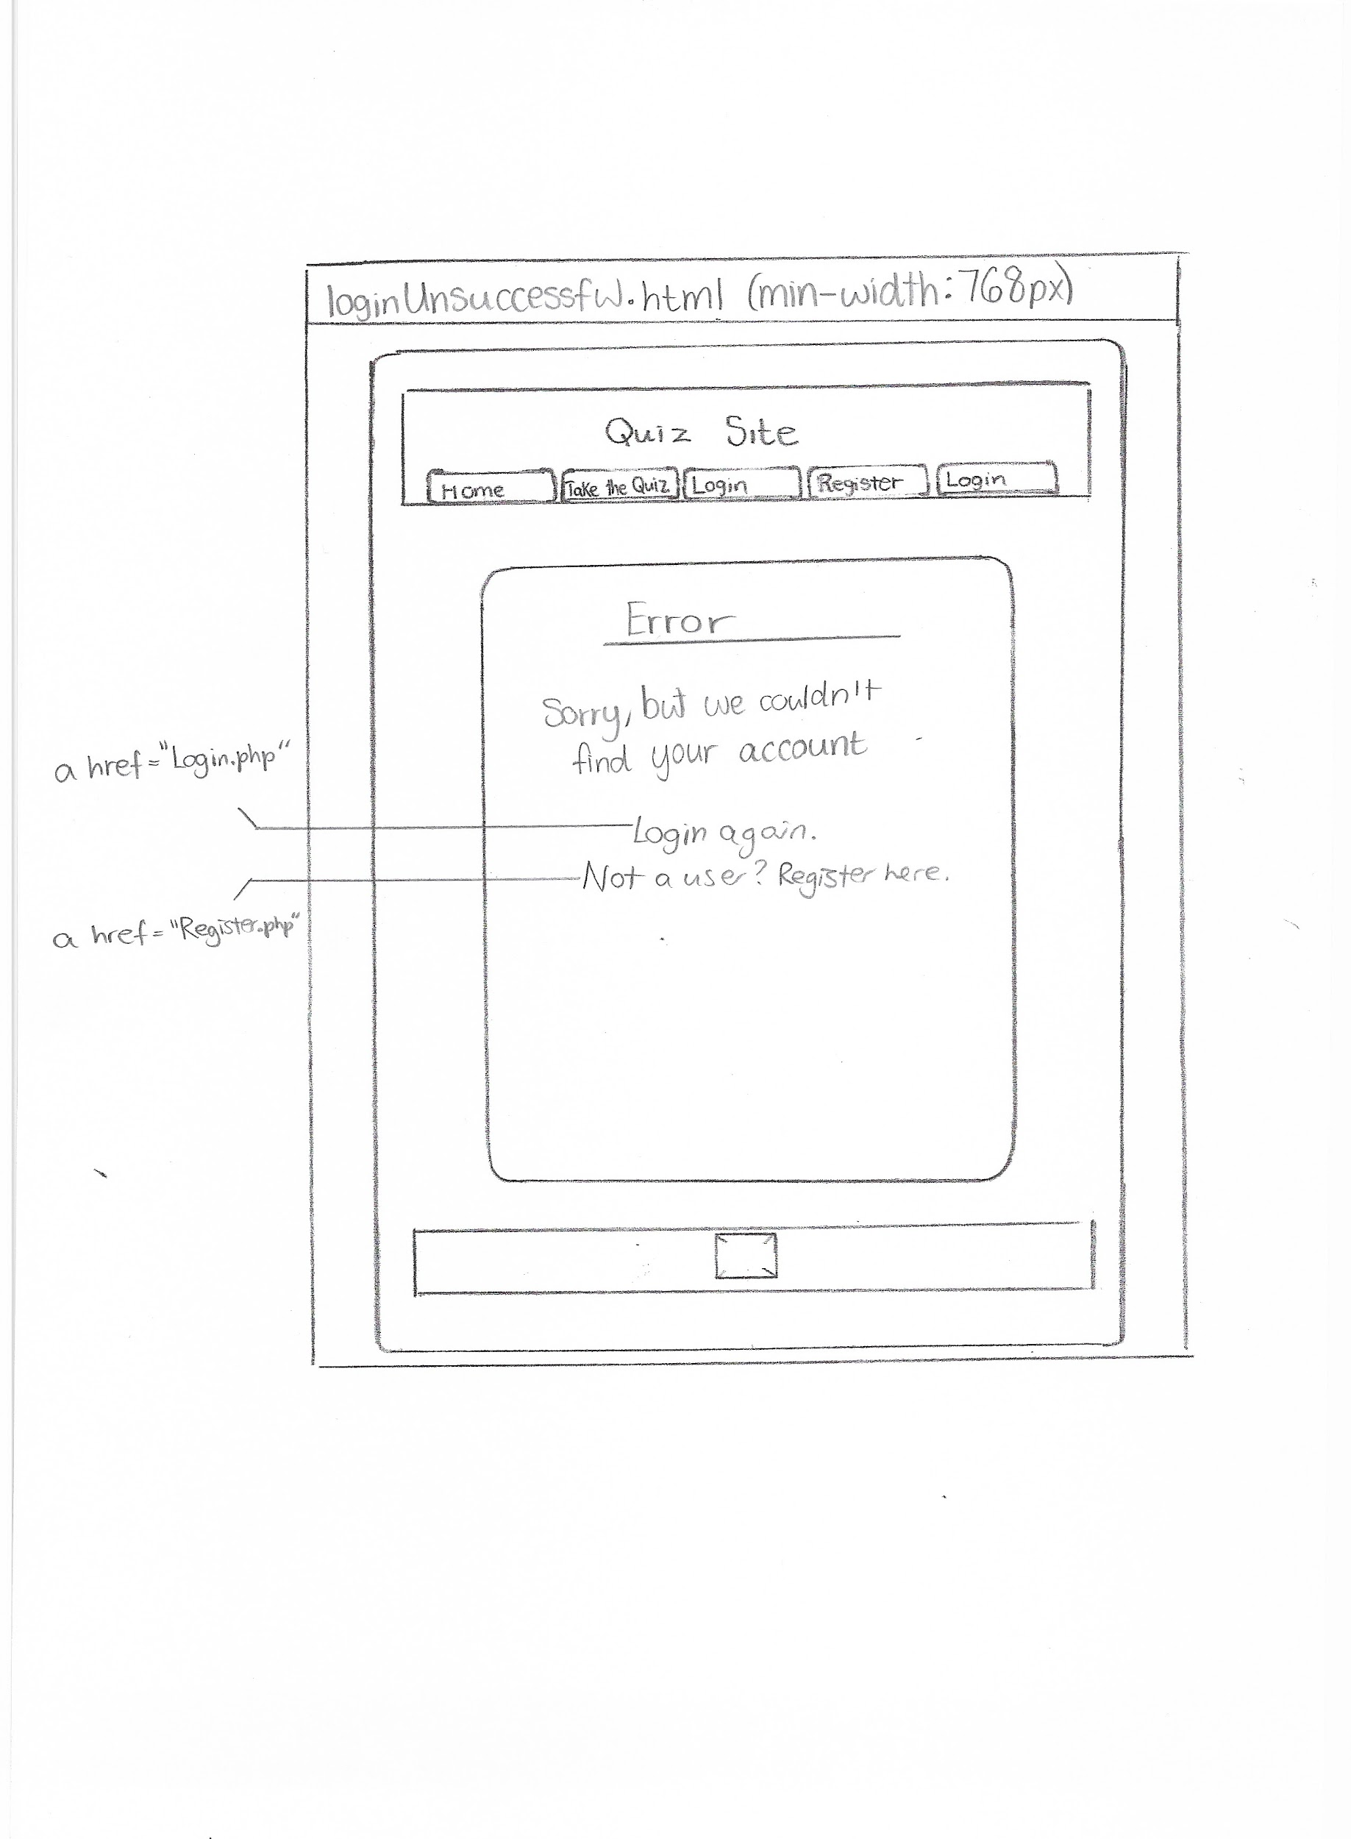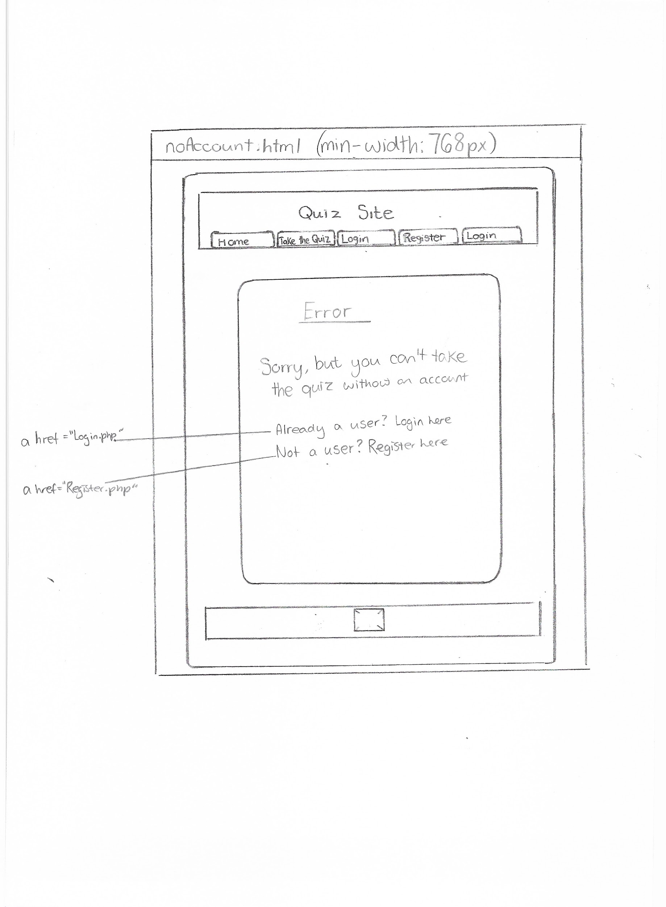

#### Hierarchical Design of Website

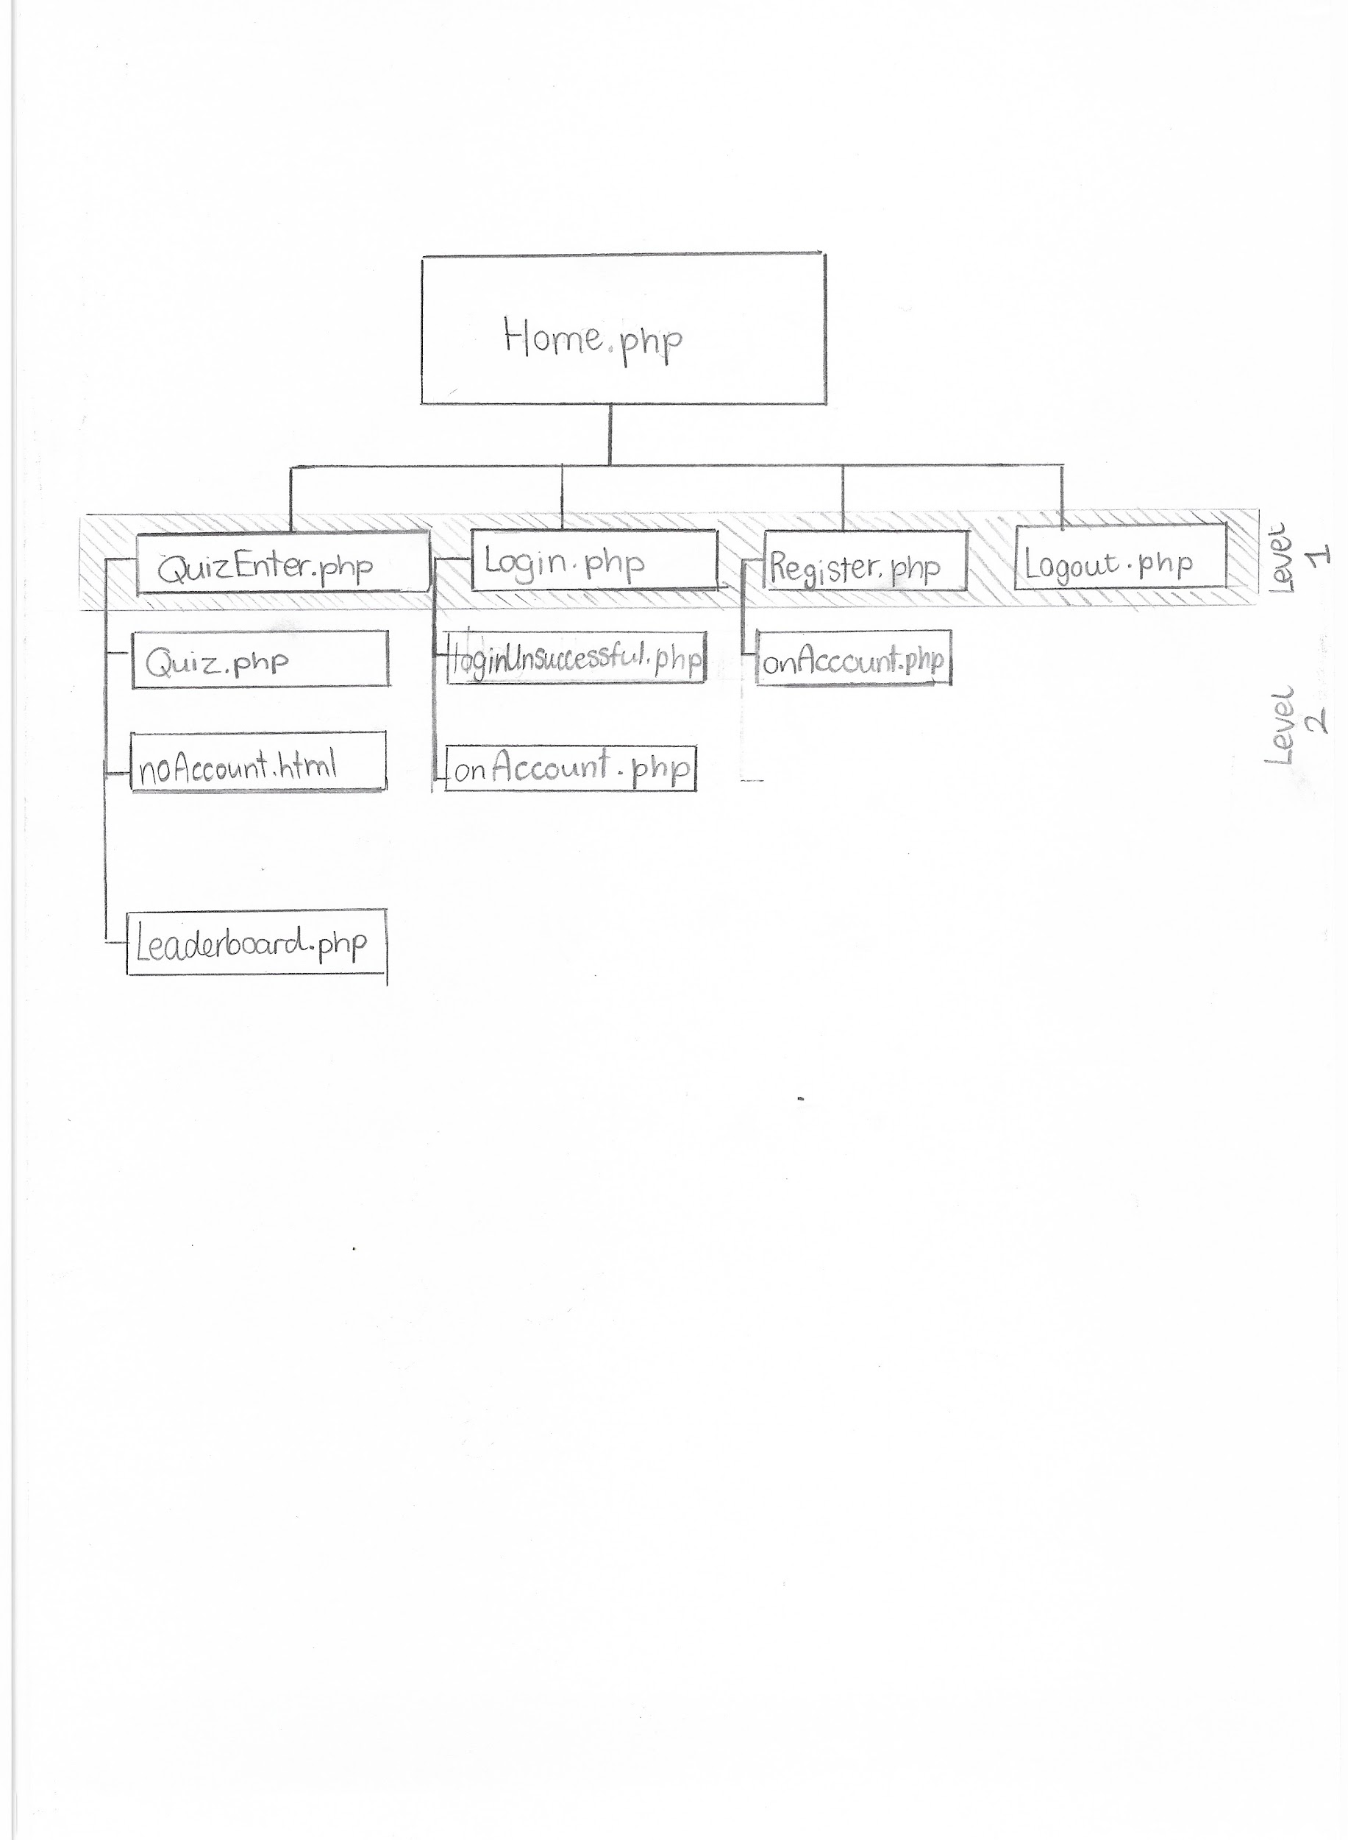

#### Code Design for PHP

Connect.php

1. Assign server connection variables
2. Open connection to quizsite database
3. If connection fails (!$conn), then exit current script and echo connection error message

newUser.php

1. Include Connect.php
2. Start session
3. Receive user and pass from Register form
4. Assign user as username and pass as password
5. Validate inputs and if they are invalid then exit current script and echo error message
6. Execute the SQL query 1 **(refer to SQL query designs)** on connection
7. If rows returned is greater than 0, then set session variable userError as true and redirect to Register.php
8. Else, execute SQL query 2
9. Set session variable currentUser as username
10. Redirect to Home.php
11. Close connection

loginUser.php

1. Include Connect.php
2. Start session
3. Receive user and pass from Login form
4. Assign user as username and pass as password
5. Validate inputs and if they are invalid then exit current script and echo error message
6. Execute the SQL query 3 on connection as $result
7. Set $count as number of rows returned for SQL query 3
8. For each row returned by $result, when $count=1,set session variable currentUser as current row’s username and redirect to Home.php
9. If $count!=”1”, redirect to loginUnsuccessful.php
10. Close connection

Response.php

1. Start session
2. Set $time as session variable time minus 1000
3. Set session variable time as $time
4. Echo $time

getQuestions.php

1. Include Connect.php
2. Execute SQL query 4 on $result
3. For each row returned on $result, echo each question and its distractors within a div element corresponding to its ID (so for questionID 1, the div element would be called Q1, etc.)
4. . Close connection

calcuateScore.php

1. Include Connect.php
2. Start session
3. Set $usertime as session variable time
4. For count = 1 to 10

4.1. Set $postVal = “ans” + $count

4.2. If $postVal is NULL, add “” to $answers[]

4.3. Else, add $postVal to $answers[]

4.4. Add 1 to $count

1. Set $score as 0
2. Set $iterationVal as 0
3. For each array item in $answers[] = $val

7.1. Add 1 to $iterationVal

7.2. If $val is not null, execute SQL query 5 on $result

7.3. For each returned by result...

7.4. Set $rightAns as current row’s answer field

7.5. If $val is equal to $rightAns, add 1 to $score

1. If statement

8.1. If $usertime is greater to or equal to 70000, then multiply $score by 2

8.2. Elseif $usertime is between values 69000 and 31000, then multiply $score by 1.5 and round $score

8.2. Elseif $usertime is between values 30000 and 10000, then multiply $score by 1.25 and round $score

8.3. Else, multiply $score by 1

1. Require updateLeaderboard.php
2. Redirect to Leaderboard.php
3. Close Connection

updateLeaderboard.php

1. Include Connect.php
2. Set $currentUser as session variable currentUser
3. Set $usertime as session variable time divided by 1000
4. Execute SQL query 6 on $result
5. If $result does not return a row number equal to 1 then

5.1. Execute SQL query 7 on $resultNew

5.2. Get the value of the id (generated with AUTO_INCREMENT) from query 7 and store as $lbRank

5.3. Execute SQL query 8 on $resultLbRank

1. Else, execute SQL query 9 on $resultUpdate
2. Close connection

sortLeaderboard.php

1. Include Connect.php
2. Start session
3. Execute on query 10 on $result
4. Set up table with headings “Rank”, “Username”, “Score” and “Time Completed”
5. Set $count as 0
6. For each row returned by result

6.1. Add 1 to $count

6.2 Echo $count under table heading “Rank”

6.3. Echo current row’s username under table heading “Username”

6.4. Echo current row’s leaderboardScore under table heading “Score”

6.5. Echo current row’s timecompleted under table heading “Time Completed”

1. End loop
2. End table
3. Close connection

Quiz.php

1. Start session
2. If session variable current user does not exist/undefined (so, if no account is in use), redirect to noAccount.html

3.1. For function showQ1(), set display for element ID Q1 to block. For elements Q2 to Q10, set display to none.

3.2. For function showQ2(), set display for element ID Q2 to block. For elements Q1, Q3 to Q10, set display to none.

3.3. For function showQ3(), set display for element ID Q3 to block. For elements Q1 to Q2, Q4 to Q10, set display to none.

3.4. For function showQ4(), set display for element ID Q4 to block. For elements Q1 to Q3, Q5 to Q10, set display to none.

3.5. For function showQ5(), set display for element ID Q5 to block. For elements Q1 to Q4, Q6 to Q10, set display to none.

3.6. For function showQ6(), set display for element ID Q6 to block. For elements Q1 to Q5, Q7 to Q10, set display to none.

3.7. For function showQ7(), set display for element ID Q7 to block. For elements Q1 to Q6, Q8 to Q10, set display to none.

3.8. For function showQ8(), set display for element ID Q8 to block. For elements Q1 to Q7, Q9 to Q10, set display to none.

3.9. For function showQ9(), set display for element ID Q9 to block. For elements Q1 to Q8, Q10, set display to none.

3.10. For function showQ10(), set display for element ID Q10 to block. For elements Q1 to Q9, set display to none.

4.1. Set count as 90000

4.2. For each 1000ms, do…

If count is equal to 0, stop loop

Else, take 1 from count

Execute Response.php

4.3. End loop

4.4. Set quizTime as 90000 + 1000

4.5. For each 1000ms, do…

Set timeLeft as quizTime take 1000

Display timeLeft to user

Set quizTime as timeLeft

If quizTime < 0…

Stop loop

Send “Time is up!” to display

Submit form with id quiz

4.6. For function “clearIntervals()”, end both timed-based loops (4.5 and 4.2)

5. For button “Q1”, call function “showQ1()”...Do likewise, eg: for button “Q10”, call function “showQ10()”

6. Call getQuestions.php

6.2. Onclick for input type=submit, call “clearIntervals”

Logout.php

1. Start session
2. If session variable current user does exist (so, if account is in use)...

2.1. Echo “Logout successful!”

2.2. Unset all session variables

2.3. Destroy session

3. Else...

3.1Echo “No account in use.”

Home.php

1. Start session
2. If session variable current user does not exist/undefined…

2.1. Echo “Welcome” (unpersonalised message)

1. Else

3.1. Echo “Welcome “ + session variable current user (personalised message)

Leaderboard.php

1. Call sortLeaderboard.php

On submitting form on Login.php, call loginUser.php

On submitting form on Register.php, call newUser.php

### **Database Design**

#### Data Dictionary

|  |  |  |  |  |  |  |
| --- | --- | --- | --- | --- | --- | --- |
| Entity Name: Question | | | | | | |
| Attribute Name | Key | Type | Size | Required | Validation | Sample Data |
| questionID | PK | int |  | Yes | Auto increment | 1 |
| questionTitle |  | varchar | 500 | Yes |  | What is the capital of France? |
| distractor1 |  | varchar | 500 | Yes |  | Berlin |
| distractor2 |  | varchar | 500 | Yes |  | London |
| distractor3 |  | varchar | 500 | Yes |  | Paris |
| distractor4 |  | varchar | 500 | Yes |  | Tokyo |
| answer |  | varchar | 500 | Yes |  | Paris |

|  |  |  |  |  |  |  |
| --- | --- | --- | --- | --- | --- | --- |
| Entity Name: User | | | | | | |
| Attribute Name | Key | Type | Size | Required | Validation | Sample Data |
| username | PK | varchar | 50 | Yes |  | Quizmaster11 |
| password |  | varchar | 50 | Yes |  | Abc123 |
| leaderboardRank | FK | int |  | No | Existing from Leaderboard table | 3 |

|  |  |  |  |  |  |  |
| --- | --- | --- | --- | --- | --- | --- |
| Entity Name: Leaderboard | | | | | | |
| Attribute Name | Key | Type | Size | Required | Validation | Sample Data |
| leaderboardRank | PK | int |  | Yes |  | 3 |
| leaderboardScore |  | int |  | Yes |  | 10 |
| timecompleted |  | int |  | Yes |  | 30000 |

#### SQL Query Designs

1.

|  |  |
| --- | --- |
| Fields/Calculations | username |
| Tables/Queries | user |
| Criteria | username=’$username’ |
| Grouping |  |
| Having |  |
| Sort Order |  |

2.

|  |  |
| --- | --- |
| Fields/Calculations | INSERT values (username=$username, |
| Tables/Queries | user |
| Criteria |  |
| Grouping |  |
| Having |  |
| Sort Order |  |

3.

|  |  |
| --- | --- |
| Fields/Calculations | * |
| Tables/Queries | user |
| Criteria | username =’$username’ AND password = ‘$password’ |
| Grouping |  |
| Having |  |
| Sort Order |  |

4.

|  |  |
| --- | --- |
| Fields/Calculations | * |
| Tables/Queries | question |
| Criteria |  |
| Grouping |  |
| Having |  |
| Sort Order |  |

5.

|  |  |
| --- | --- |
| Fields/Calculations | answer |
| Tables/Queries | question |
| Criteria | questionID = $iterationVal |
| Grouping |  |
| Having |  |
| Sort Order |  |

6.

|  |  |
| --- | --- |
| Fields/Calculations | * |
| Tables/Queries | user |
| Criteria | Username = ‘$currentUser’ AND leaderboardRank IS NOT NULL |
| Grouping |  |
| Having |  |
| Sort Order |  |

7.

|  |  |  |
| --- | --- | --- |
| Fields/Calculations | INSERT INTO leaderboard(leaderboardScore, timecompleted) |  |
| Tables/Queries | leaderboard, user |  |
| Criteria | VALUES($score,$timecompleted) WHERE user.username = $currentUser |  |
| Grouping |  |  |
| Having |  |  |
| Sort Order |  |  |

8.

|  |  |
| --- | --- |
| Fields/Calculations | UPDATE username, leaderboardRank SET leaderboardRank = $lbRank |
| Tables/Queries | user |
| Criteria | username=’$currentUser’ |
| Grouping |  |
| Having |  |
| Sort Order |  |

9.

|  |  |  |
| --- | --- | --- |
| Fields/Calculations | UPDATE leaderboardScore,timecompleted SET leaderboardScore = $score, timecompleted = $usertime |  |
| Tables/Queries | leaderboard |  |
| Criteria | leaderboardRank = [INNER QUERY] | INNER QUERY   |  |  | | --- | --- | | F/C | leaderboardRank | | T/Q | user | | C | username=’’’$currentUser’ | |
| Grouping |  |  |
| Having |  |  |
| Sort Order |  |  |

10.

|  |  |
| --- | --- |
| Fields/Calculations | * |
| Tables/Queries | user, leaderboard |
| Criteria | leaderboardScore IS NOT NULL AND user.leaderboardRank = leaderboard.leaderboardRank |
| Grouping |  |
| Having |  |
| Sort Order |  |

#### Entity Relationship Diagram

